[Getting Spring Cloud Data Flow up and Running](https://app.pluralsight.com/player?course=java-microservices-spring-cloud-coordinating-services&author=richard-seroter&name=18412e5c-f352-4c68-b927-09d077a9ebba&clip=7&mode=live" \t "psplayer)

Ref: <https://cloud.spring.io/spring-cloud-stream-app-starters/>

<https://cloud.spring.io/spring-cloud-stream-app-starters/>

> java -jar spring-cloud-dataflow-server-local-1.7.4.RELEASE.jar --spring.datasource.url=jdbc:mysql://localhost:3306/test --spring.datasource.username=root --spring.datasource.password=root --spring.datasource.driver-class-name=org.mariadb.jdbc.Driver --spring.rabbitmq.host=localhost --spring.rabbitmq.port=5672 --spring.rabbitmq.username=guest --spring.rabbitmq.password=guest &

>java -jar spring-cloud-dataflow-shell-1.3.0.M1.jar

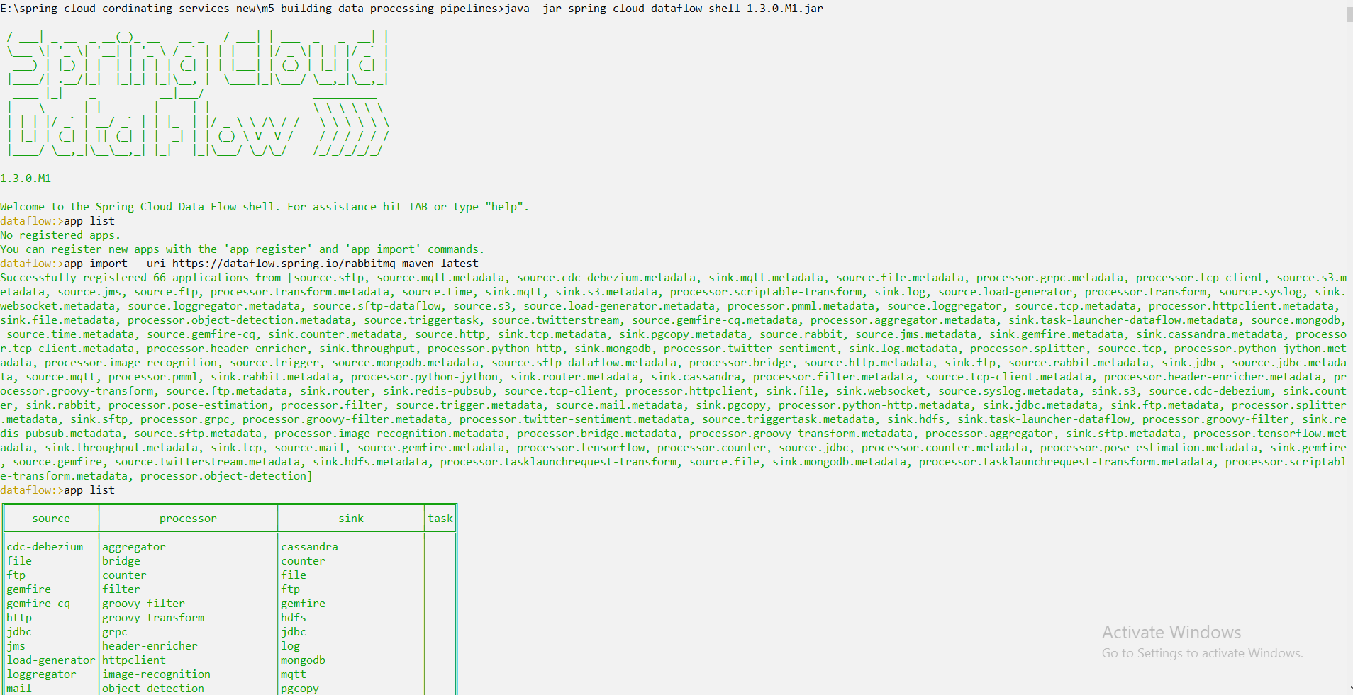

dataflow:>stream create --definition "http --port=8086 | file --directory=C:/csv/dataflow-out --suffix=txt --name=output" --name hello

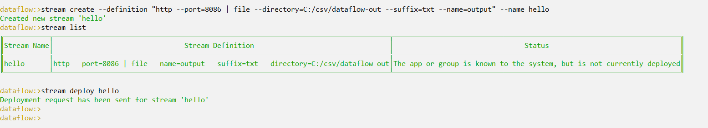

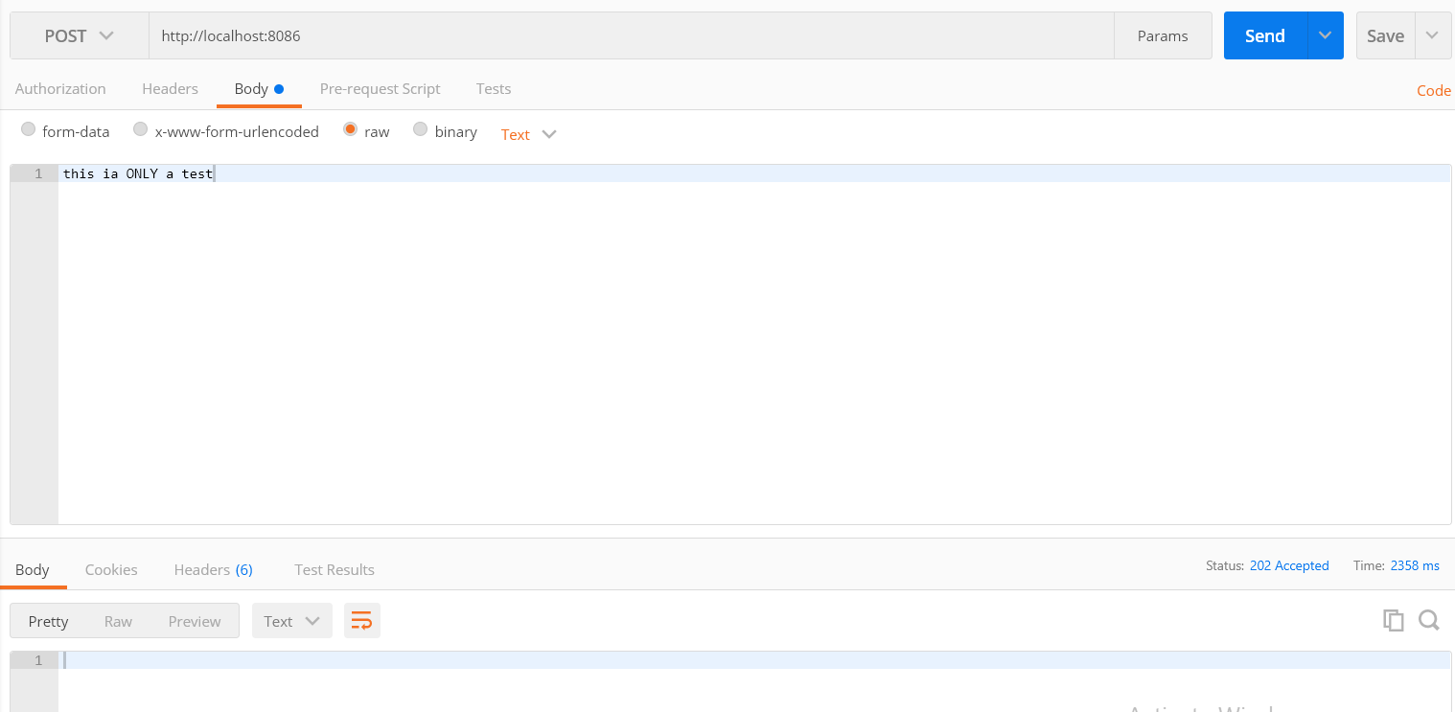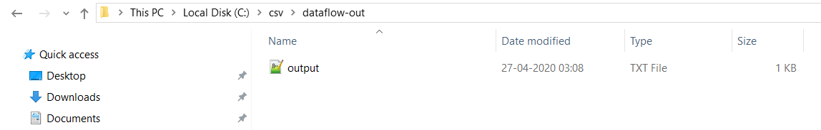

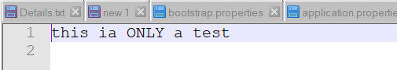

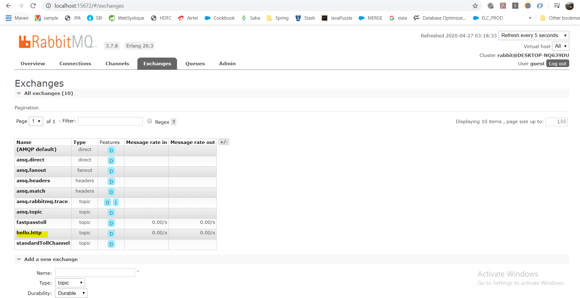

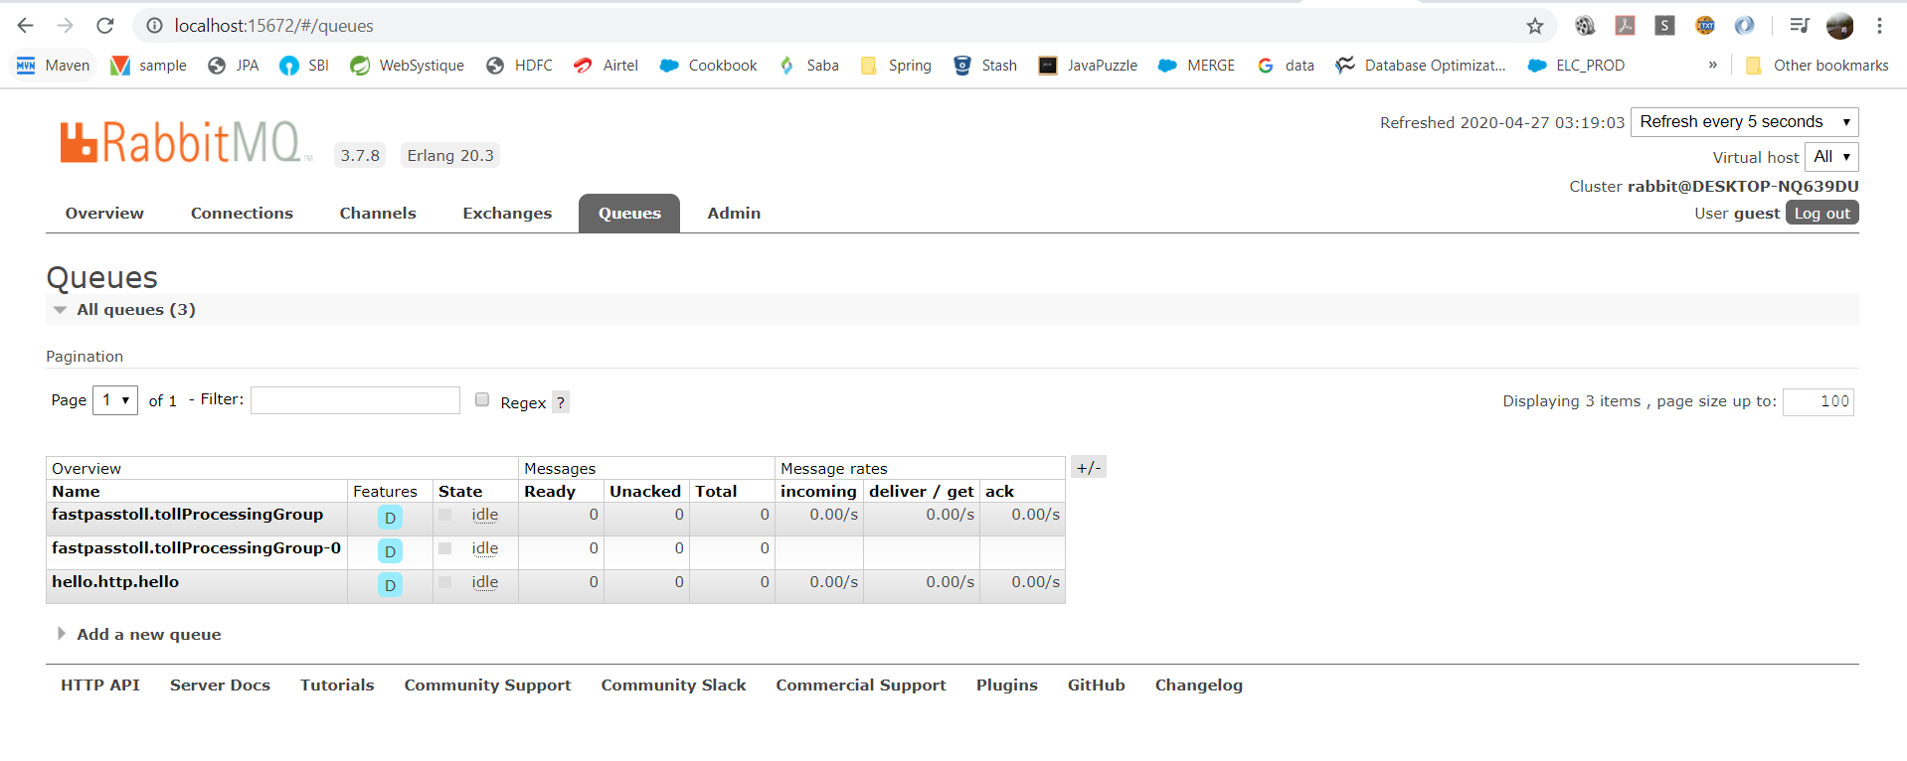

stream create --definition "file --directory=C:/csv/dataflow-in --mode=lines | transform --expression=payload+' | processed=true' | output: file --directory=C:/csv/dataflow-out --suffix=txt --name=outputZ" --name stream1



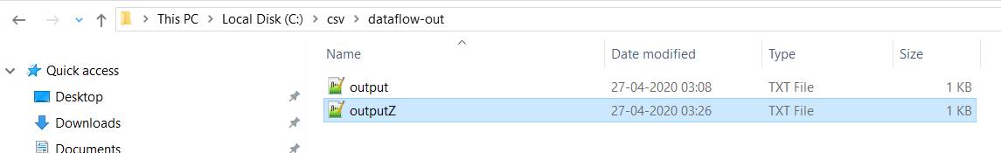

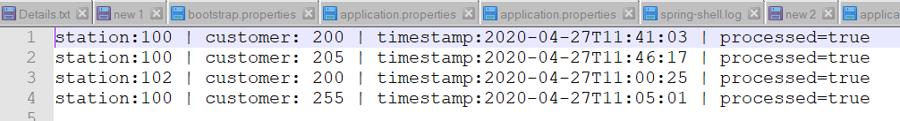

app import --uri https://dataflow.spring.io/task-maven-latest

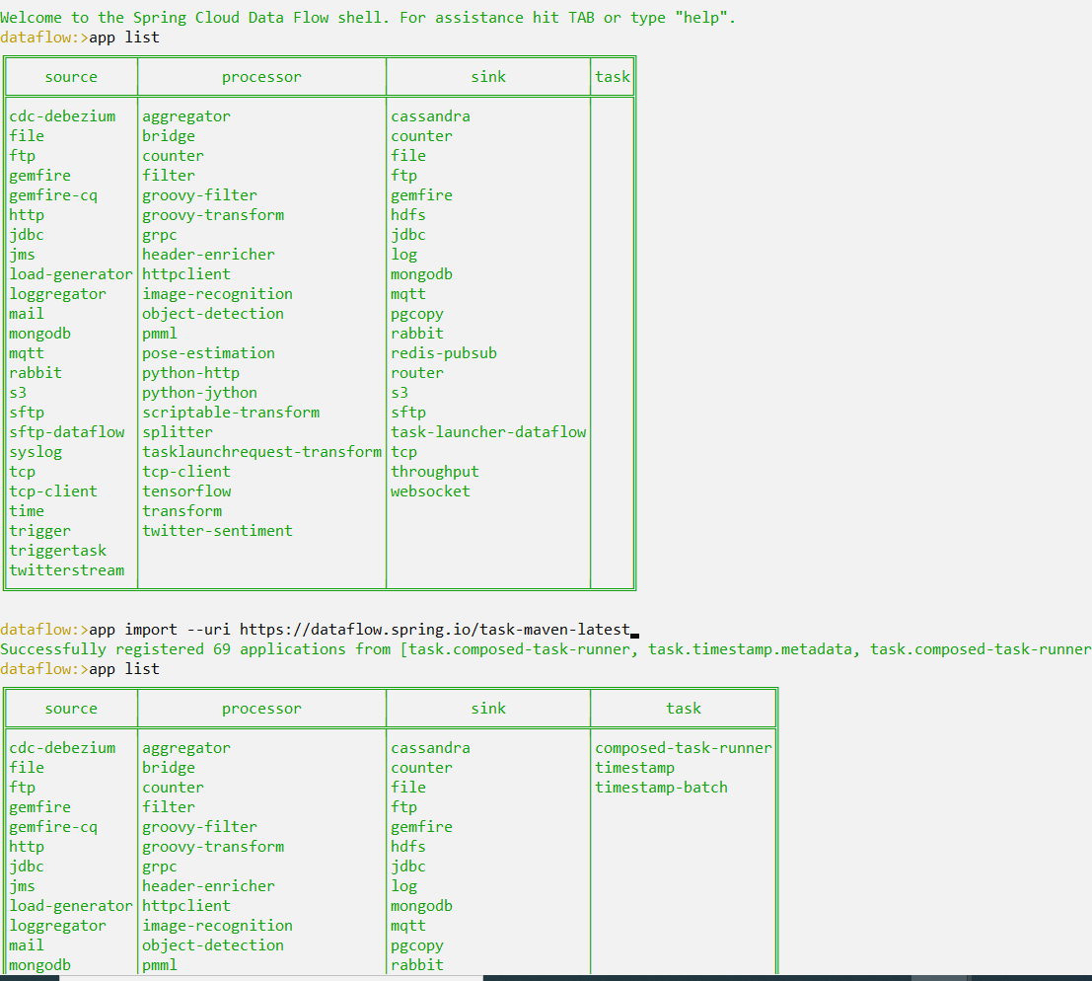

dataflow:>task create demotask --definition "timestamp --format=\MM\yy\"

Created new task 'demotask'

dataflow:>task list

╔═════════╤══════════════════════════╤═══════════╗

║Task Name│ Task Definition │Task Status║

╠═════════╪══════════════════════════╪═══════════╣

║demotask │timestamp --format=\MM\yy"│UNKNOWN ║

╚═════════╧══════════════════════════╧═══════════╝

